

# Accessibility Guide for Hampton Court Palace

[hamptoncourt@hrp.org.uk](mailto:hamptoncourt@hrp.org.uk), [033 3320 6000,](tel:033%203320%206000) <www.hrp.org.uk>

**Contact for accessibility enquiries: Lucy Hutchings**

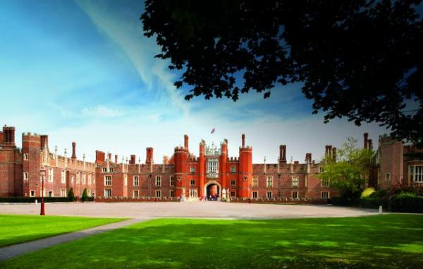

### Welcome

Hampton Court Palace - managed by Historic Royal Palaces, an independent charity - is in south-west London and has over 500 years of history to discover. The home of Henry VIII, his wives and children, the palace is the greatest and most authentic Tudor experience in the world.

But Hampton Court isn't just a Tudor Palace. Explore our Baroque Palace, built for William III and Mary II. Its spectacular views and decorative interiors provide a fascinating glimpse of Stuart and Georgian privilege.

The palace grounds and gardens are equally stunning. From the world famous maze and grape vine to the ornamental gardens, exploring outside is a magical treat too.

## At a Glance

### Level Access

* There is level access from the main entrance to:
  + Dining Table
  + Henry VIII's Apartments
  + Pre-purchase desk in the Ticket Office
  + Base Court accessible toilets
  + Palace Shop
  + Henry VIII's Kitchens
  + William III's Apartments
  + The Georgian Story
  + The Kitchen Garden
  + The Formal Gardens
  + The Magic Garden (April to October only)
* There is level access from the car park to:
  + Tiltyard and Wilderness Gardens

### Access with steps

* There are steps from the main entrance to:
  + Privy Kitchen Cafe

### Hearing

* We have a hearing loop in Till points in the Ticket Office, shops and cafes. .
* Some staff have disability awareness, BSL and Next Generation Text training

### Visual

* Glass doors and full-height windows have contrast markings.
* The walls and the doors have high colour contrast.
* Some parts of the venue have low lighting.
* We have display information in audio, braille and large print.
* We have information in braille and large print.

### General

* We have a complimentary ticket policy for personal assistants.
* There is at least 1 public toilet for disabled visitors.
* Some staff have disability awareness training.

## Getting here

Hampton Court Palace  
East Molesey  
Surrey  
KT8 9AU

#### Travel by public transport

* You can get to Hampton Court Palace by bus, train and boat or ferry.
* There are two bus stops close by: Hampton Court Gardens (by the entrance to the gardens near the Maze on Hampton Court Road) and Hampton Court Palace (by Trophy Gate, near the Ticket Office). The bus stop is 0.2 miles / 0.3 km from Hampton Court Palace.
* The nearest train station is Hampton Court Station. The train station is 0.3 miles / 0.5 km from Hampton Court Palace.
* The nearest port is Turks Pier on the River Thames. The port is 0.2 miles / 0.3 km from Hampton Court Palace.
* Hampton Court Palace is in travelcard zone 6.

#### Parking

* There is parking near the venue. There are accessible parking spaces. Parking is not free.
* From the car park to the entrance, there is level access. There is a car park on site which has nine disabled parking bays. Parking is currently free for blue badge holders; the cost is £1.60 per hour for those without a blue badge. All car parking bays are available on a first come first served basis and cannot be booked in advance.  
  - Additional parking is available on Hampton Court Green - where there is a coach park as well as car park - and at Hampton Court train station.  
  - Cars and taxis may pull in next to the Ticket Office to drop off if the car park is full. Minibuses too large to fit into the palace car park may do the same before going off-site to park in the coach bays on Hampton Court Green.  Motorhomes and caravans should also use the coach bays on Hampton Court Green.

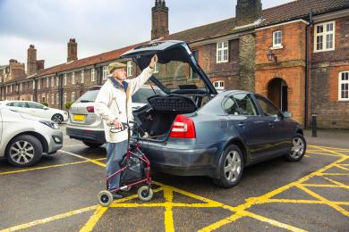  
Disabled parking bays in the palace car park

## Arrival

#### Path to main entrance

* From the street to the main entrance, there is level access.
* The path is 2000mm wide, or more.

#### Main entrance

* The main entrance has level access.
* The door is 2000mm wide.
* The gate will be open whenever the palace is open. The approach is tarmac and bonded gravel but entry is straight onto cobbles once inside.

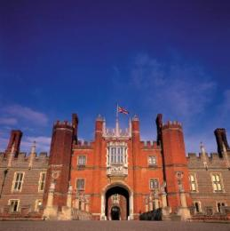  
The entrance to Hampton Court Palace

## Getting around inside

#### Visual Impairment - General Information

* We have contrast markings on all glass doors, contrast markings on all full-height windows and high colour contrast between walls and doorframes.
* Some parts of the venue have low lighting.

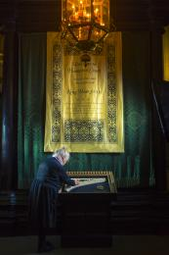  
Low light levels at the start of Henry VIII's Apartments

#### Lift

* We have 1 lift.
* You can get a lift to all floors.

#### Lift to the first floor

* The lift door is 900mm wide.
* The lift is 1220mm wide. The lift is 1710mm deep.
* Lift users have to be accompanied by a member of staff as it opens into an area off the visitor routes which is normally locked. Please make your way to the East Gate and speak to the Warders there if you wish to use the lift.

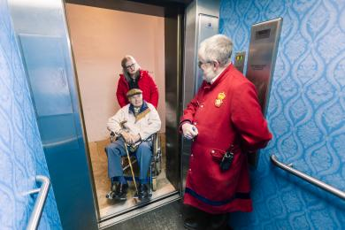  
Entering the lift

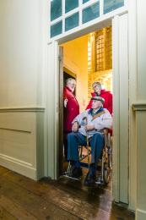  
Exiting the lift onto the first floor

#### Ticket/ information desk

#### Pre-purchase desk in the Ticket Office

* From the main entrance to the desk, there is level access. The desk has a low section.
* The desk has an induction loop wired into it for hearing aid users.  
  - Although primarily there for people needing to collect pre-purchased or online tickets, it can also sell day tickets to anyone who enters the Ticket Office.

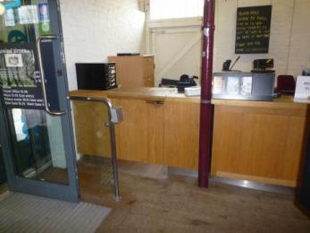  
The pre-purchased ticket desk

#### Things to See and Do

* We have a complimentary ticket policy for personal assistants.
* We have performances with: British Sign Language interpreted.
* We have display information in: audio, braille and large print.
* We have a designated quiet space.

#### Henry VIII's Apartments

* From the main entrance to this area, there is level access. There is a lift.
* Some display information is low, for wheelchair users. There are seats.
* Some videos have subtitles.
* Although our displays don't have flashing lights, visitors are allowed to take personal photographs - which means there will often be camera flashes, and sometimes a lot of them.  
  - Henry VIII's Apartments are the most popular part of Hampton Court Palace and can often be very crowded. They include the Great Hall, Great Watching Chamber, Processional Route, Council Chamber and Haunted Gallery.

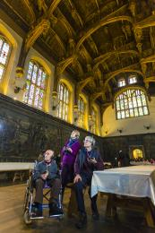  
Visitors in the Great Hall using the audio guides

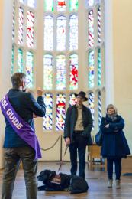  
Deaf visitors on a BSL tour in the Great Watching Chamber

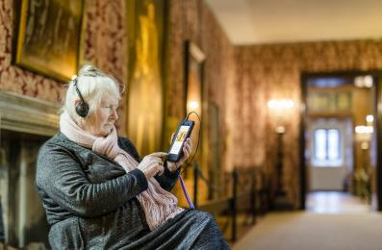  
Visitor with an audio tour in the Processional Route

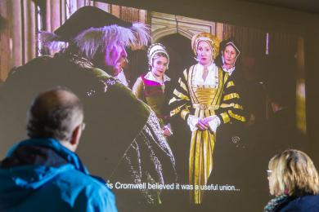  
Introductory film about Henry VIII's wives, with subtitles

#### Public toilet

#### Base Court accessible toilets

* There is a public toilet for disabled visitors.
* From the main entrance to the public toilet, there is level access.
* There are five accessible toilets inside the palace and three more in the palace gardens. Two of the accessible toilets inside the palace (off Base Court) have a small lip at the entrance.  
  - There is also an accessible toilet on the first floor near the Queen's Stairs.  
  - Hampton Court Palace does not have a Changing Places Toilet. The nearest are at: HFT Kingston Resource Centre, New Malden, KT3 3LJ; Chessington World of Adventures Resort, Chessington, KT9 2NE; Kew Gardens, TW9 3AB.

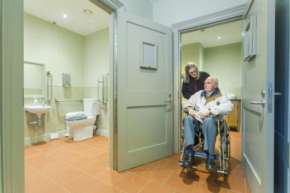  
Base Court accessible toilets

#### Shop

#### Palace Shop

* From the main entrance to the shop, there is level access. The route through the shop is 800mm wide, or more.
* The Palace Shop is opposite the Ticket Office, so visitors do not need an admission ticket to browse or shop in it.

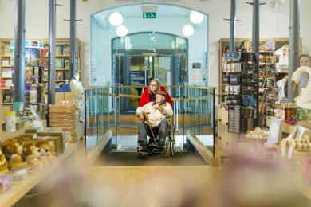  
The entrance to Palace Shop

#### Place to eat and drink

#### Privy Kitchen Cafe

* From the main entrance to the dining area, there are 2 steps. There is no lift and no ramp.
* To get to a table, there are no steps.
* The route through the dining area is 800mm wide, or more.
* There is no background music.
* The table and plates have high colour contrast.
* We cater for vegetarian and gluten free (celiacs) specific diets.
* The Privy Kitchen Cafe offers soup, pies and sandwiches along with cake and crisps, and hot and cold drinks.

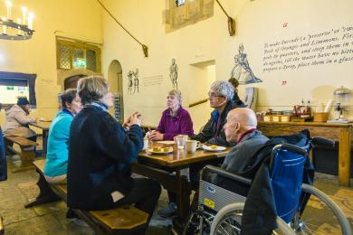  
Privy Kitchen Cafe seating area

#### Place to eat and drink

#### Tiltyard Cafe

* From the main entrance to the dining area, there is level access. To get to a table, there are no steps.
* The route through the dining area is 800mm wide, or more.
* There is no background music.
* The table and plates have high colour contrast.
* We cater for vegetarian and gluten free (celiacs) specific diets.
* The Tiltyard Cafe offers hot meals and salads, as well as sandwiches, cakes and drinks (hot and cold).

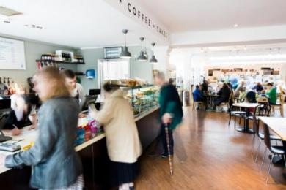  
The Deli Counter in the Tiltyard Cafe

#### Henry VIII's Kitchens

* From the main entrance to this area, there is level access. There is a permanent ramp.
* Henry VIII's Kitchens are all on the ground floor. Most of the floor surfaces are cobbles and there are some very small rooms which can easily get congested. There is also a real fire in the final room and cooks dressed in historic costume working in there during the summer.

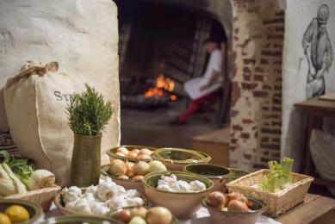  
Henry VIII's Kitchens

#### William III's Apartments

* From the main entrance to this area, there is level access. There is a lift.
* William III's State Apartments are on the first floor, so accessible via the staff-operated lift.  
  - His Private Apartments are on the ground floor.   
  - Together they are William III's Apartments and part of the 17th century Baroque building at Hampton Court Palace.

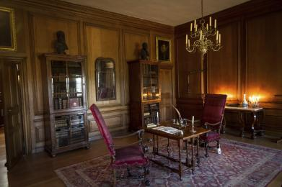  
The King's Private Drawing Room, part of his Private Apartments on the ground floor

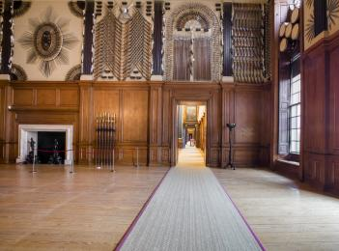  
The King's Guard Chamber and State Apartments, on the first floor

#### The Georgian Story

* From the main entrance to this area, there is level access. There is a lift.
* The Georgian Story is about when George I and George II lived at Hampton Court Palace in the early 18th century.

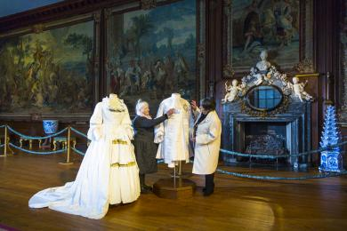  
Paper figures in the Public Dining Room, The Georgian Story

## Getting around outside

#### The Kitchen Garden

* From the main entrance to the gardens, there is level access.
* The Kitchen Garden is a one acre vegetable garden. It has wide paths around the sides but narrow paths through the vegetable beds which can have plants spilling over them at the height of the growing season.

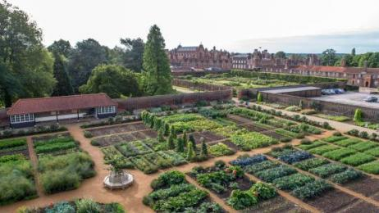  
The Kitchen Garden, looking towards the palace

#### Rose Garden

* The Rose Garden is next to the palace car park. It has benches on the paths around the edges but visitors can sit on the grass between the rose beds if they wish.

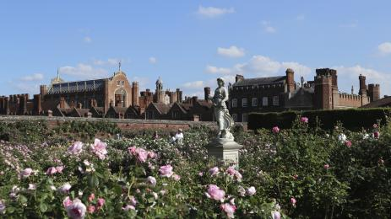  
The Rose Garden, looking towards the palace

#### Picnic Area

#### Tiltyard and Wilderness Gardens

* From the car park to the picnic area, there is level access. You can bring your own food to the picnic area.
* Visitors may picnic in any of the palace gardens. There are benches, deckchairs (summer months only) and some picnic tables, and visitors can sit on the grass.

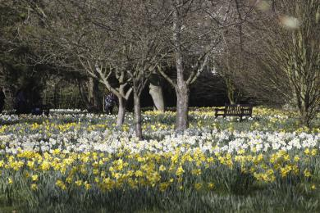  
The Wilderness Garden in spring

#### The Formal Gardens

* From the main entrance to this area, there is level access. The entrance is 1500mm wide.
* The Formal Gardens can only be reached via the palace so visitors will need to have a palace entrance ticket.  
  - There are three gates from the East Front into the Formal Gardens. Visitors can also reach them from Base Court via the entrance to the Mantegna Gallery.  
  - The Formal Gardens consist of the Great Fountain Garden, the Privy Garden, the Pond Gardens and the 20th Century Garden. The Great Vine and the Royal Tennis Court are also in the Formal Gardens.

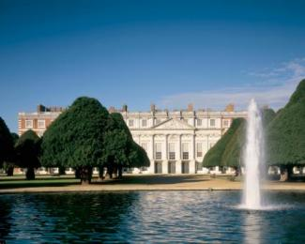  
The Great Fountain Garden

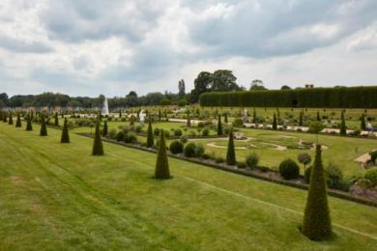  
The Privy Garden

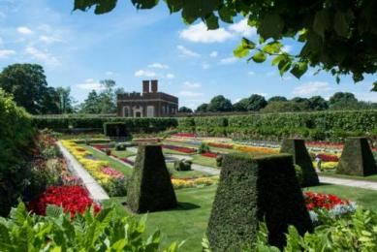  
One of the enclosed Pond Gardens

#### The Maze

* The Maze is included in palace admission tickets, but anyone who doesn't have a palace ticket can buy a Maze only ticket at the entrance.  
  - The world famous Hampton Court Palace Maze has a third of a mile of narrow paths and 2 metre high hedges. The aim is to get to the centre, from where there is a short cut to the exit.  
  The paths are only 1-2 feet wide so are too narrow for mobility scooters.

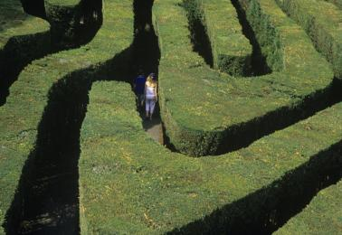  
The Maze

#### The Magic Garden (April to October only)

* From the main entrance to this area, there is level access.
* The Magic Garden is included in palace admission tickets, but anyone who doesn't have a palace ticket can buy a Magic Garden & Maze only ticket at the entrance.  
  - The Magic Garden is an enclosed children's play area near the Kitchen Garden, themed to represent the history of Hampton Court Palace. It is aimed at primary-school-aged children, but famlies are encouraged to play together and all equipment is suitable for adults.  
  - It is very popular and queues can build up during the summer; a timed exit system using wristbands is in operation on these occasions.  
  We have periodic relaxed sessions - called 'Rise and Roar' - when capacity is reduced and external noises removed as much as possible. These start at 9am (so an hour before the Magic Garden usually opens) and participants get one and half hours before other visitors are allowed in. All attendees MUST register in advance (even if they don't need to buy an admission ticket e.g. they are Members) so that we can ensure the number of people in the Magic Garden does not exceed the reduced capacity during the 'Rise and Roar' session. Please see our website for dates.

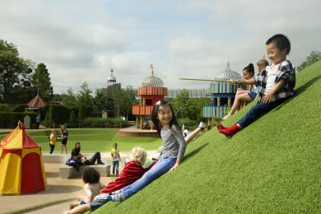  
The Magic Garden

## Customer care support

#### Accessibility equipment

* We provide wheelchairs. We have a hearing loop in Till points in the Ticket Office, shops and cafes. .
* There are seats in most rooms and we have a number of objects in Henry VIII's Apartments and Henry VIII's Kitchens that can be handled.
* For a list of more items, please go to https://www.hrp.org.uk/hampton-court-palace/visit/accessibility/#gs.4PucqQ0.
* Assistance dogs requiring the toilet should use the palace gardens, which surround the building on three sides.

#### Emergency evacuation procedures

* We have emergency evacuation procedures for disabled visitors.
* Our alarm system is a sounder but all visitors should follow the instructions of the Front-of-House Staff, who will be able to guide them to the nearest safe exit.  
  - Please follow any instructions from the staff as it is possible that an evacuation may be required but the alarm doesn't sound.  
  - All our accessible toilets have pull-cord alarms that link back to our Control Room, but they don't flash.

#### Customer care support

* Some staff have disability awareness training.
* Some staff have Next Generation Text training.
* Some staff have BSL training.
* We have information in braille and large print.
* We provide some additional services for visitors with disabilities to help them get the most from their visit but most require staff or volunteer assistance so must be pre-booked well in advance.  
  - However, our guidebook is available in Braille and can be borrowed at any time from the Information Centre. We also have audio tours in versions suitable for partially sighted visitors.

Guide last updated: 11 August 2020